**Final Year Project Proposal**

Software Engineering Department

NED University

**Travelog Pakistan**

Group Leader Name : Faraz Ali SE-054

Member #01 : Hassan Raza SE-053

Member #02 : Syed Ali Mehdi SE-063

**MOTIVATION :**

There are a lot of tour operators operating in our country and using their platforms, but it’s more than just difficult to find the best choice regardless of knowing any tour operator. We, as tourists, have also been to tours, and have visited a lot of websites in this domain, but we could not find a platform which can act as a marketplace for tour operators, where can they advertise themselves and their tours, but also manage their business without needing their domain and hosting, which is another headache. For this purpose, we informally asked certain tour operators about their operations and what they think about that platform, and they told us that we are getting clients from certain areas and that a platform like OLX, Zameen.com should be present for tour operators too, through which they can advertise themselves and the users can easily find them. The aim of this study was to identify how travel agencies struggle with their traditional business and marketing strategies, turns out their issues were unaddressed. The sole purpose of the project is to facilitate tour operators in this era, when tourism industry is on a high, to properly expose them to a large audience, and in future, managing their operations through our back offices, which we are going to provide them.

Also, as tourists ourselves, we felt the need of a platform where we could find all the trusted and verified tour agencies, to compare them and their tour packages, in order to find the most suitable one for us. Since there is not a platform like such in market, we thought why not we come up with a solution ourselves which is usefull for our client.

**OVERVIEW :**

The core idea behind the project with description is as follows:

* **SIGNIFICANCE/ IMPORTANCE:**

Tourism is significant from the point-of-view of people and the government as well in the way that people like to travel, while travel agencies and governments like to generate money out of it. We, as people also love to travel and this recent inclination toward the tourism industry was our main motivation behind pursuing this idea as our FYP and we also got a project with industrial linkage.

The scope of tourism industry and our project, which are solely related, is never-ending and ever-growing. And recent attention is being paid to tourism sector by the Government of Pakistan too. In these conditions with all the potential in Pakistan's landscape, the project is more than just practical.

With increasing tourism , number of tour operators and tourists increases , but no platform is there in the market which enables users to connect and view all of the business associated with tourism industry, and that is what we are going to provide.

Academically, this is an important project because we are using state-of-the-art technologies to build the applications and interfaces like React, React-native, REST APIs etc. We are using Scrum for the project life cycle and tools like MS Azure Dev-ops for project management. We are also planning to incubate this idea.

We strongly believe that this idea has what it takes to make an impact on the industry because it has never been done before and it serves the purpose for both the tourists and tour operators. This project has the ability to solve the problem of having to find the suitable agent, listing, and a marketplace for the operators, at the same time. Moreover, we are going to give them back-offices to manage their business without needing their own websites.

* **DESCRIPTION OF PROJECT :**

The project is based to serve both the tourists and the tour operators. Projects provides a marketplace/ listing for the tour operators, which platforms like OLX, Zameen.com are providing for other kind of businesses. Tour operators will be given the options of advertising them on a platform that is solely made for that purpose, hence not limiting them to get customers they know, or are from the same geographical location. They could go country-wide, business will be able to upload their tours and services, and maintain their portfolio for the world to see. And in our future plans is making their lives even easier by providing them an interface( dashboard) to manage their business, and by bringing other businesses related to the tourism industry to our platform, hence enabling to manage their whole business operations through us. We will give them leads if any customer asks for a customized tour, and hence we are providing a viable solution for them.

For tourists like us, a platform to find the best tour operator to go on a vacation with. Searching through filters will make the user's life easy in finding out the viable options, by having a look at the rating and reviews of operators given by people themselves, and by checking if the operator is verified. Furthermore, they can see the past trips being organized by a particular tour operator to get the idea. We will notify the users if any updates happen in their follow-ups. Plans also include enabling the tourists to ask for a customized trip, which will then by passed to operators. And when all the businesses associated with tourism industry will be by our side, tourists will be able to book trips and manage through us.

* **BACKGROUND OF PROJECT :**

The idea comes from our personal experiences when we had to find a perfect operator to go to a trip with. Furthermore, we asked nearby operators about their businesses and extracted the issues and enhancements we could make in this industry. We searched for the big fishes in this industry like Expedia, Trip-advisor etcetera and entities in Pakistan like FindMyAdventure to get the idea. We tried to find any competitors out there, but the idea is not implemented by anyone yet. We closely follow any tourism-related articles to be aware of the advancements in the industry and for that very purpose we plan to incubate our idea.

**METHODOLOGY :**

We will be working on SCRUM methodology by following these :

* **DESIGN PHASE :**

We will work on wireframing and create wireframes for the purpose of arranging elements to best accomplish a particular purpose . Then we will create mockups by using Mockplus software which helps in teaching, demonstration, design evaluation, promotion, and other purposes. After mockups, we will design use case diagrams and Entity Relationship Diagram (ERD) diagrams for the implementation.

* **IMPLEMENTATION PHASE :**

After the results of design phase we will now start developing our project .  The tools we are using for our project is Android Studio/Visual Studio as the whole work in based on React Native (framework of JavaScript). MySQL will be used to store and manage the massive data of our customers i.e. Database. NodeJS is our required server side development tool.

* **TESTING PHASE :**

In this phase, we will find out the errors in our application before deploying it to its end users. The application will be given to beta users to test it and will also be given for stress testing to check whether the application is able to handle stress without getting crashed. Our moto here is to test whether our intended purpose is according to the mentioned details and is working perfectly without any failure.

* **EVALUATION PHASE :**

Following modules of Travel-Log application will be evaluated:

1. Number of users using the application.
2. Satisfaction of user.
3. All the features of Travel-Log application are fulfilling its objectives.

**SALIENT FEATURES :**

* **LISTING OF TOUR OPERATORS :**

Enables users to find desired tour operator by applying filters according to their needs, and by checking reviews. Users can follow tour operators to get notified. Enables tour operators to be easily found by tourists from all over the country without any limitation of area.

* **LISTING OF ALL ACTIVE TOURS :**

Users can find a tour of their choice by applying filters according to their requirements and follow it to get updates about the tour. User can view the destinations and details about the tour including itinerary etc.

* **TOUR OPERATOR PROFILES**

Users can go to profiles of tour operators to see what tours they have organized and what were the reviews of the people that went with them. Contact details of operators will also be visible to users. Users can follow operators.

* **SEARCHING :**

Searching is one of the most important things in these kind of listing services like OLX,Zameen.com etc., so a lot of attention will be given to searching. Users will be able to search by applying specialized filter according to what they want to search.

* **AUTHENTICATION :**

Sign-in options for both tourists and tour operators with sign-in from Facebook/Google options will be there. Whether or not the user is signed up or not will differ in the rights.

* **ADD A TOUR :**

Specialized app for tour operators will be built to enable operators to add tours and edit them if they will to. They can add images and videos and all the details about the tour. They will have to add the tour plan and important details.

* **CREATE PROFILE :**

The tour operators app will enable them to create their profile by adding their contact details and all business information they want the tourists to see. Their past and upcoming tours will be visible there. Rating and reviews will also be visible. They can also add a gallery featuring their media.

* **DESTINATIONS :**

Major attractions, famous places will also be contained in a view where users can surf to, to read and get information about famous places and view images of the place. Users can find which tours are taking to a particular destination from there. Suggested seasons will be there as well.

The above features will be present in our MVP (Minimum Viable Product), that will be launched in the market with all above functionalities. Upon getting registrations, we will upgrade our service, by including more and more functionalities because the scope of this domain is never-ending.

Our upcoming plans include:

* booking trips through our app.
* Customized tour request leads to operators.
* Other business (hotels, car services etc.) related to tourism.
* Whole business operations like trips

**PROJECT PLANNING :**

First we will identify the project vision, business goals , user stories and clarifying what we need to achieve together and according to them we will design our sprints and project timeline and processes need to get there and also . Then we develop an action plan for how we are going to take this forward.

**REQUIRED HARDWARE AND SOFTWARE :**

**HARDWARE :**

* Android Phone with version 6.0+ (preferred Lollipop)
* I-phone 5 and above

**SOFTWARES :** We will be using list of software of different purposes

* Microsoft Azure Dev-ops (For Project Management)
* Android Studio (For Simulation and Development Environment)
* Visual Studio Code (As a Code Editor)
* MySQL (To manage Database)
* NodeJS (Server Side Development)
* Mockplus (Mockups and Prototyping Tool)
* Slack (Team Coordination)

**DETAILED DIAGRAM OF THE OVERALL SYSTEM :**

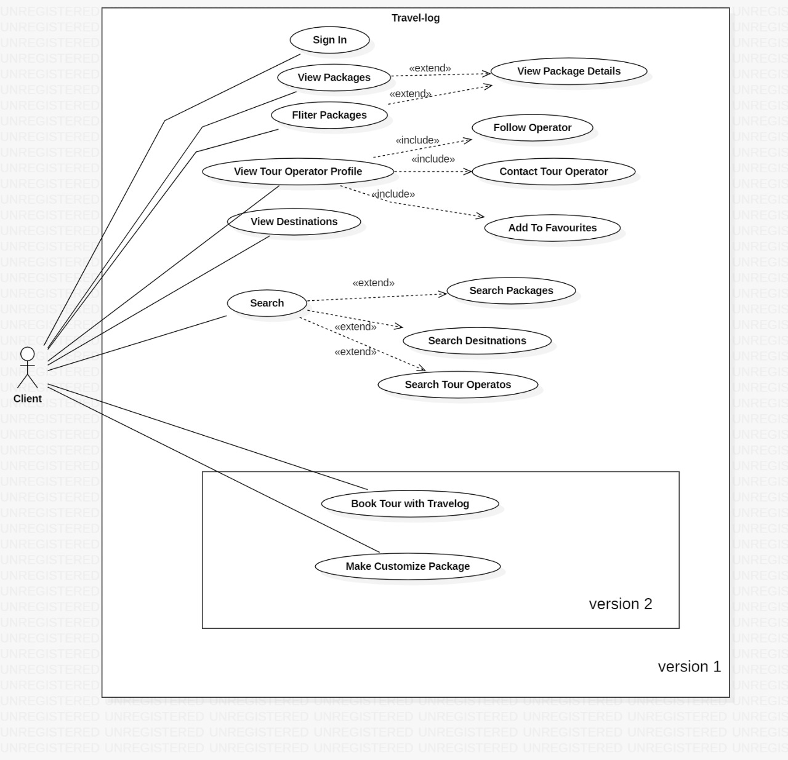

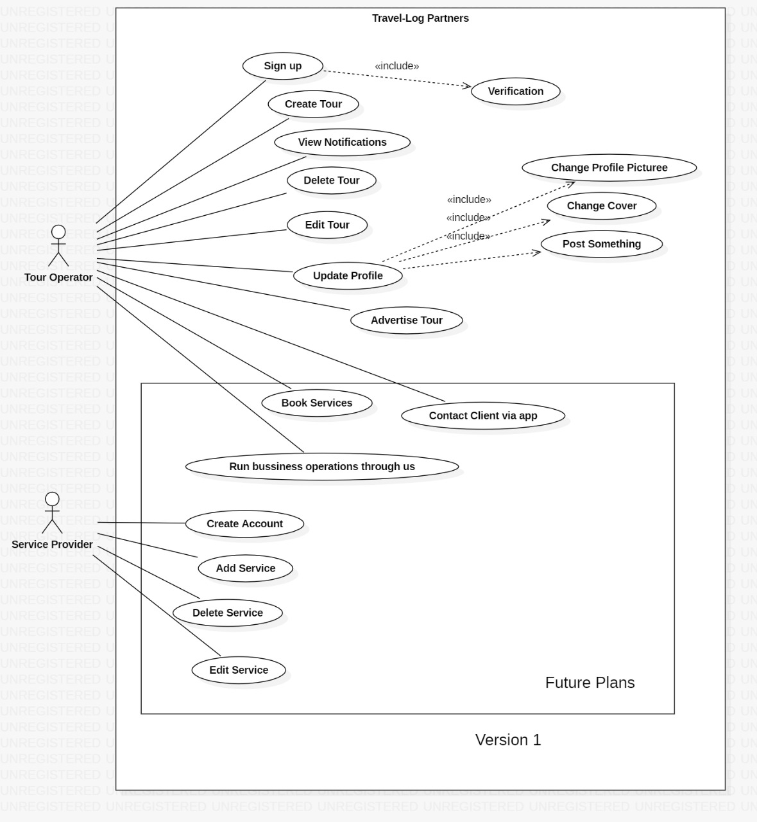

**References :**

* **Expected Internal Advisor**

Dr. Shehnila Zardari

Department of Computer Science & Software Engineering

* **Expected External Advisor**

Tahir Ali

Lead Software Engineer

Emaratech, Dubai.